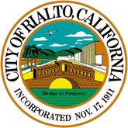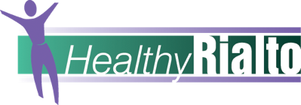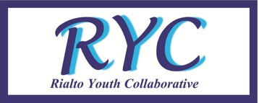

Shades of Blue
in partnership with Rialto Mayor Deborah Robertson, Council and the city's Healthy Rialto and youth programs
presents
Rialto Aerospace Academy
Frisbie Middle School, 1442 N. Eucalyptus Avenue, Rialto, CA 92376
Feb 20, 27, Mar 5, 12, 19, 2016
8:00 AM – 12:15 PM

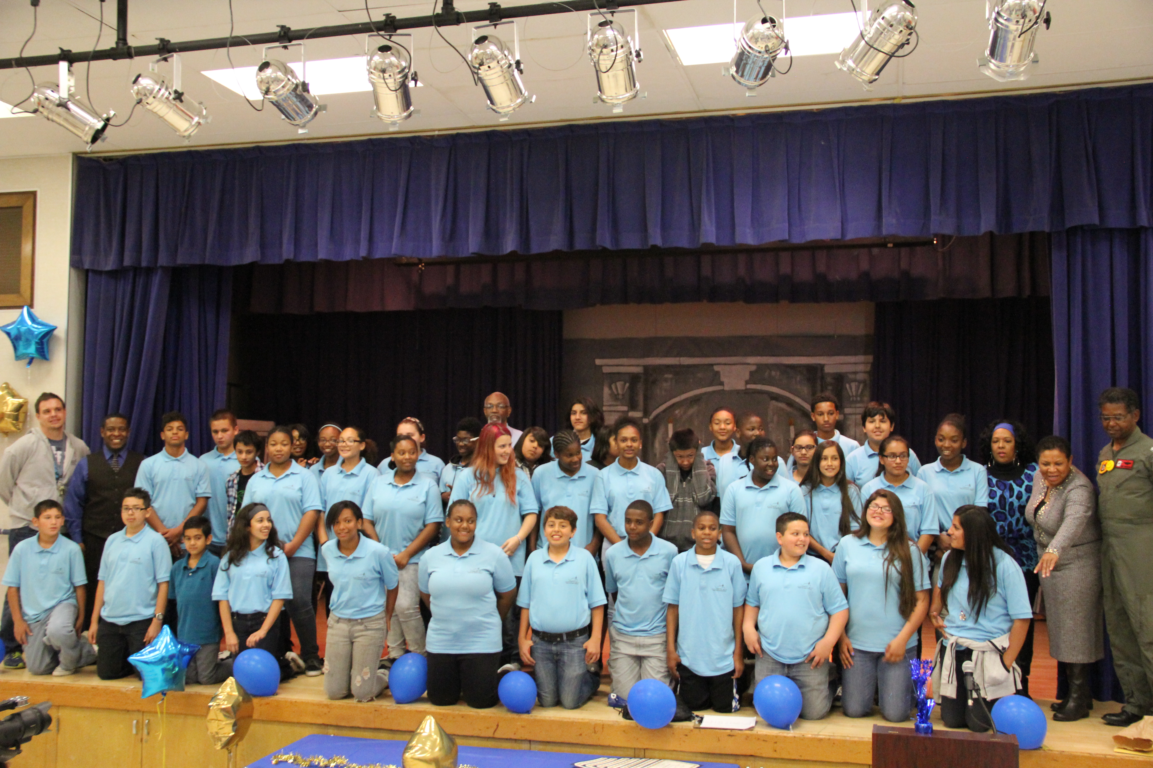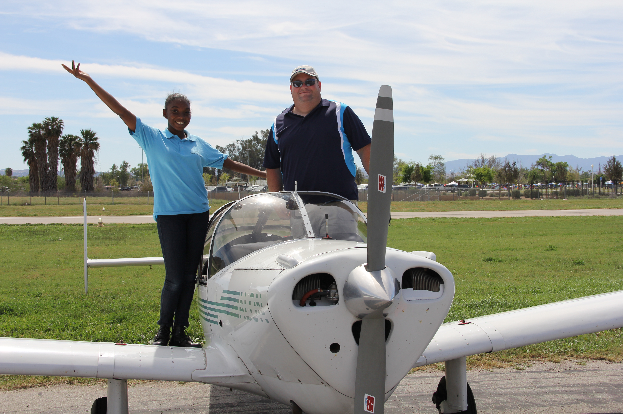

Applications are available at www.ourshadesofblue.org on the coming events calendar.
The academy is open to students enrolled in the Rialto Unified School District system, ages 13 and older.
There is no enrollment fee for this academy – students will be instructed on the applications of Science, Technology, Engineering, and Mathematics (STEM) subjects to the aerospace industry and potential career choices. Students who successfully complete the academy will be offered the opportunity for an orientation flight in an airplane.
If you have questions please contact the Shades of Blue Academy Director, Tony Marshall, at f4tony@aol.com or 760-247-0456.

